Experiment – 3
ID3 Algorithm
Demonstrate the working of the decision tree based ID3 algorithm. Use an appropriate data set for building the decision tree and apply this knowledge to classify a new sample.
Aim:
To demonstrate the working of the Decision Tree based ID3 algorithm using the Play Tennis dataset and classify a new sample based on the generated decision tree.
Algorithm:
Step 1: Start.
Step 2: Import the required Python libraries.
Step 3: Load the Play Tennis dataset from the CSV file.
Step 4: Separate the input features (Outlook, Temperature, Humidity, Wind) and the target variable (PlayTennis).
Step 5: Convert the categorical data into numerical values using Label Encoder.
Step 6: Train the Decision Tree model using the entropy criterion (ID3 algorithm).
Step 7: Generate and display the decision tree.
Step 8: Provide a new sample to the trained model.
Step 9: Predict whether the new sample belongs to Yes or No (Play Tennis).
Step 10: Display the predicted result.
Step 11: Stop.
Program:
# Import libraries
import pandas as pd
from sklearn.preprocessing import LabelEncoder
from sklearn.tree import DecisionTreeClassifier, plot_tree
import matplotlib.pyplot as plt

# Load dataset
data = pd.read_csv("play_tennis.csv")
print("Dataset:\n")
print(data)
# Separate features and target
X = data.drop("PlayTennis", axis=1)
y = data["PlayTennis"]
# Encode categorical data
encoders = {}
for column in X.columns:
le = LabelEncoder()
X[column] = le.fit_transform(X[column])
encoders[column] = le
target_encoder = LabelEncoder()
y = target_encoder.fit_transform(y)
# Train ID3 Decision Tree (Entropy)
model = DecisionTreeClassifier(criterion="entropy", random_state=42)
model.fit(X, y)

# Display Decision Tree
plt.figure(figsize=(12,8))
plot_tree(
model,
feature_names=X.columns,
class_names=target_encoder.classes_,
filled=True,
rounded=True,
fontsize=10
)
plt.show()
# Predict a new sample
# Outlook=Sunny, Temperature=Cool, Humidity=High, Wind=Weak
new_sample = pd.DataFrame({
"Outlook": ["Sunny"],
"Temperature": ["Cool"],
"Humidity": ["High"],
"Wind": ["Weak"]
})
# Encode the new sample
for column in new_sample.columns:
new_sample[column] = encoders[column].transform(new_sample[column])

prediction = model.predict(new_sample)
print("\nNew Sample:")
print({
"Outlook":"Sunny",
"Temperature":"Cool",
"Humidity":"High",
"Wind":"Weak"
})
print("\nPrediction:")
print("Play Tennis =", target_encoder.inverse_transform(prediction)[0])
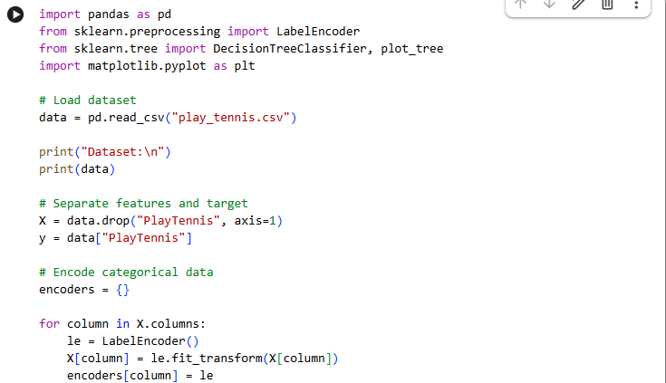
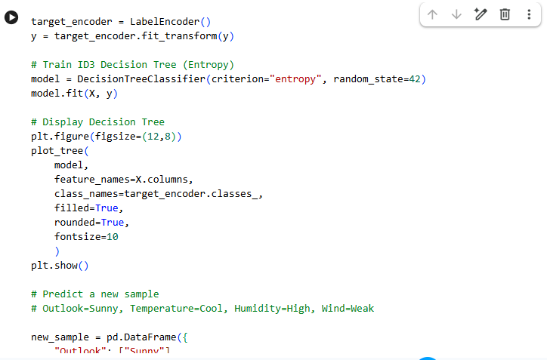
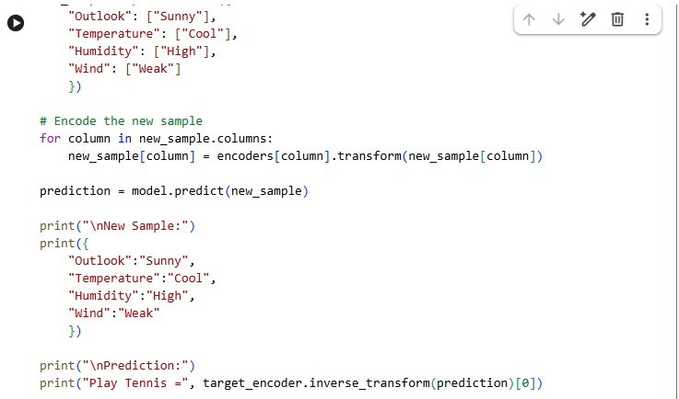
Output:
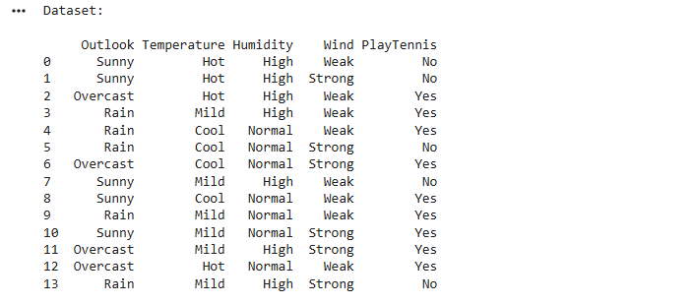
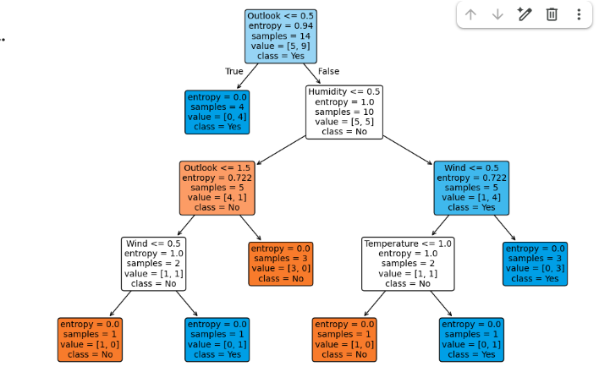
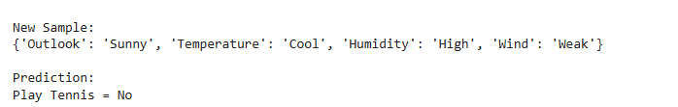
Result:
The Decision Tree based ID3 algorithm was successfully implemented using the Play Tennis dataset. The decision tree was generated based on Information Gain (Entropy), and the new sample:
- Outlook: Sunny
- Temperature: Cool
- Humidity: High
- Wind: Weak
was classified as:
Prediction: Play Tennis = No
Hence, the experiment was executed successfully, and the ID3 algorithm correctly classified the given sample based on the trained decision tree.

